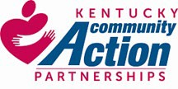
Community Action Kentucky

RFP For Financial / Accounting Services

The information provided here in the “RFP Scope of Work and Description” is believed to be accurate at the time it was written. Any bidder should seek to clarify any information that they believe to be ambiguous. Any and all information presented in this Description of Work is subject to change at any time for any reason without notice.

Contents
Community Action Kentucky 1
Request for Proposal - Financial and Accounting Services 2
Instructions, please read carefully: 3
Background 5
1 - Chief Financial Officer (Contract) 9
2- Accounting Services AR/AP 13
2.1 - Accounts Payable 13
2.2 - Accounts Receivable 14
3 - Program Invoicing and Billing “Pass-Through” Funding 16
4 - Payroll 19
5 - Human Resources 21
6 - Financial Software 23

Request for Proposal - Financial and Accounting Services

Community Action Kentucky, Inc. (CAK), a non-profit 501(c)(3) organization, is requesting proposals for professional Financial and Accounting Services.
Respondents may submit proposals for one or more of the RFP’s components. Proposals will be accepted until 4:00 PM EST on Monday, September 28, 2026.
Responses should be emailed to: financialservicesrfp2026@capky.org
Any costs incurred by the respondent in preparing the RFP are the responsibility of the applicant.
Questions regarding the proposal should be directed to Ricky Baker, CAK Executive Director, at the email address: financialservicesrfp2026@capky.org. Questions must be submitted by 4:00PM EST August 31, 2026. Questions and Answers will be aggregated, anonymized, and submitted to all interested parties via email.
Upon delivery, all materials submitted in response to this RFP become the property of CAK and may be appended to any formal documentation establishing a contractual relationship between CAK and the selected respondent. The respondent shall not submit any information that is of a proprietary nature or mark its proposal as proprietary or confidential.
The respondent agrees in submitting a proposal that the proposal may not be modified, withdrawn, or canceled by the respondent for ninety (90) calendar days following the submittal date. The respondent’s proposal will be valid for a period of ninety (90) calendar days following the submittal date.
Community Action Kentucky expects to make a selection by December 11, 2026. CAK reserves the right to reject any or all responses received or any part thereof or to accept any response or any part thereof when it is deemed to be in CAK’s best interest.
All entities that submitted a proposal will be notified via email of the respondent selected.
Community Action Kentucky, Inc., is a private, nonprofit corporation. It is exempt from federal income tax under Section 501(c)(3) of the Internal Revenue Code. A Board comprised of executive directors of the 23 Kentucky community action agencies governs the organization.
The mission of Community Action Kentucky is to build and strengthen the network of Kentucky’s community action agencies resulting in the improvement in the lives of the people we serve.
The following is a list of financial records: 4 bank accounts, 1 investment account, general ledger, property and equipment schedule, depreciation schedule, investments, 1 revolving loan program, 1 pass-through loan program, and payroll journals. Financial records are maintained on a computerized system. Sage Intacct is the online software system that is utilized.
Annual revenues are estimated to be $101 million, the large majority of which is subcontracted to member agencies. The net operating budget of the association is estimated to be $1.75 million.

The organization is an Equal Opportunity employer. As such, it attempts to empower all employees regardless of race, creed, color, age, sex, national origin, or disability. The respondent must work in accordance with this philosophy.

Instructions, please read carefully:
This bid package contains information about CAK to guide you toward building a proposal.
CAK’s primary objective in issuing this RFP is to identify people or firms that can meet the following:
  - Demonstrate the ability to deliver high quality services.
  - Listen to, understand and respond effectively to CAK’s unique needs and challenges.
  - Precision, accuracy and timeliness of work product.
  - Engagement in a long-term partnership.
  - Ability to enhance trust and confidence in CAK’s financial operations.
  - Fair pricing for both CAK and the respondent.

This RFP contains multiple components. CAK is requesting that respondents provide their proposal, based upon their strengths and areas of competence, for ANY or ALL of the RFP components. Please clearly indicate which components you are submitting a response for. Respondents may submit to each component individually, or any or all of the components as a combination or package. Please also indicate any component that you are not submitting a response for. (CAK is looking for a solution and will entertain alternative proposals.)
    - Chief Financial Officer (Contract) 2-Accounting Services AR/AP
3-Program Invoicing and Billing “Pass-Through Funding” 4-Payroll
- Human Resources
- Financial Software System
Pricing: CAK understands that pricing a proposal such as this will present certain challenges, particularly without firsthand knowledge of CAK’s internal operations. Therefore, it is important that you detail the scope of your proposal to describe the services that you will (and won’t) provide in your pricing proposal. CAK will consider proposals for start-up costs and ongoing costs.
CAK expects that once a respondent is selected, the respondent and CAK will engage in the development of a contract where specifics of scope and price can be negotiated.

The RFP should be submitted using the following format:

- A cover letter should include the following: Complete legal name of the respondent, address, telephone number, name and title of contact person and federal tax identification number. It should state the respondent’s ability and willingness to submit the RFP. The respondent must

provide assurance that it carries adequate general comprehensive, liability insurance coverage and that the respondent maintains bonding insurance. The respondent should indicate if it is a small or minority business.
- Provide a description of the respondent’s prior experience with nonprofits, fiscal agents, fund accounting, or with similar types of programs and funds. Names, addresses, telephone number, and number of years of experience should be included in the description.
- The structure and size of the respondent should be described.
- The qualifications of staff that will be assigned to CAK should be described. Resumes of key staff that will be assigned should be provided. Levels of supervision should be indicated.
- Assurances that the respondent is competent to perform the services and is familiar with any rules and regulations that govern federal and state grants.
- Describe how you will approach the proposed services, including the use of local / remote or onsite/offsite staff.
- Describe the resources and commitments that you will need from CAK.
- Describe how you / your firm will analyze and understand CAK’s unique requirements.
- Describe your use of technology and software.
- Describe the process of on-boarding CAK, including timeframes for transition and assurance that you will work cooperatively with the current vendor for transition.
- Describe the CAK’s ownership and portability of data and documents.
- The proposed price of the services should be indicated. A description of how the price was determined should also be included, as well as scope of work in the proposal.
- Any limitations on or additional fees should be explained.
- Signed “Certification”. (Attachment A)

Background

Community Action Kentucky (CAK) is the State Association for the 23 Community Action Agencies (CAA) in Kentucky. The 23 CAAs operate various human service programs in Kentucky’s 120 counties.
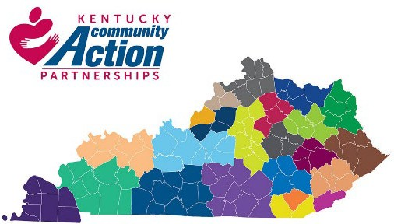
CAK is a 501(c)(3) organization governed by a 23-member Board of Directors. Each CAA has one seat on the CAK Board.

22 of the CAAs are 501(c)(3)s—aka “private” CAAs while 1 is part of the part of the Louisville Metro City government—a “public” CAA.
At the time of this RFP, CAK has 9 employees, and typically ranges from 5-11.

Figure 1: 23 Community Action Agencies by CSBG territory

Primary business operations include:
- Program Administration: CAK contracts program administration from a funder (ex: federal, state or private entities). Such programs are sub-contracted to one or more entities—typically CAAs in Kentucky.
- Fiscal Agent: CAK serves as the fiscal agent, passing finances from a funder to one or more CAAs (i.e., “Pass-Through”). CAK may be the fiscal agent in combination with program administration.
- Training and Technical Assistance (T&TA): CAK provides training and technical assistance services to CAAs. (Technical assistance here typically refers to operational assistance, not necessarily related to technology).
- Software Provider: CAK provides access to the empowOR software system for CAAs. The software provides for client case management, program management, eligibility determination, fund tracking and reporting.
- CAK has four bank accounts:
  - A general checking account,
  - An ICS sweep account to ensure fully insured funds
  - A charitable gaming account,
  - A 501(c)(4) Community Action Development Account
- CAK holds one investment account at an investment firm under the direction of the CAK Finance/Investment committee. (Respondent is not responsible for investing advice or services)
Primary Income streams include:
- Administration fees related to program operations
- Operation of T&TA grants and contracts
- Collection of association membership dues
- Return on investments Primary Expenses include:
- “Pass-Through” payments to subcontractor entities (usually CAAs) as part of the fiscal agent or program administration role.

- Expenses related to Personnel compensation, benefits, County Employee Retirement System (CERS).
- Technology, including use of empowOR software system.
- Operational expenses: office supplies, travel, building, utilities, etc.

Key Points:
- CAK largely uses “fund accounting” and currently maintains 15-20 different funds., Each fund has its own income, expenses, budget and set of rules that must be followed. Proper coding of expenses is critical to CAK operations.
- CAK’s financial operations must follow Federal and State regulations and requirements, as well as the requirements of the agreements and contracts.
- Funding streams may have allowed and disallowed costs. Controls should be put in place to reduce the risk of charging disallowed costs to funding streams.
- Accounting and finance functions are tightly woven into program operations. Systems of continuous monitoring and reporting should be implemented to ensure that costs are kept within parameters. Key Performance Indicators (KPI) should be identified and communicated regularly to CAK Staff, management, and the Program Team.
- Indirect costs- those that are not a direct charge to a funding stream—must by properly applied and remain within allowable parameters. Controls should be put in place to monitor these costs and ensure they remain within allowed parameters.
- Expenses must stay within budget for individual funding streams. Systems of continuous monitoring and reporting should be implemented to ensure that costs are kept within parameters. Key Performance Indicators (KPI) should be identified and communicated regularly to management. Regular cost projections should be communicated to CAK management.
- CAK’s financials are subject to review at any time by the CAK Board, funders, regulators and other entities. It is critical that the finances, policies, procedures, documentation be well organized and “audit ready” at all times.

At a glance:
Current annual operating budget: $1.75M net operating / $101 million total (including pass-through)
Fiscal year: Fiscal year is July 1- June 30
Annual payroll budget: $750,000 annual salary (approximate) Number of full-time staff: 6 (5-10 normal)
Number of part-time staff: 1 (at this time)
Average number of bills paid per month : 150 per month (approximately 40% of the payments are “pass-through” payments to CAAs/subcontractors). CAK utilizes BILL.COM for account payables.
Average number of receipts per month: 50-75 receivables per month. CAK does not currently accept credit card payments.

Current accounting software: Sage-Intaact
Other software used in operations: empowOR – CAK’s program management software system. Number of bank accounts: 4 banking + 1 investment account:
- A general-purpose checking account.
- An ICS sweep account to ensure all funds are fully secured
- A charitable gaming account (see gaming) (low volume)
- A 501(c)(4) Community Action Development Account (low volume)
- CAK holds one investment account with an investment firm (see investment) Number of credit cards: 4
Audit firm: RFH, PLLC, of Lexington, KY
Payroll provider: CAK currently handles payroll through a contract with Bluegrass Community Action.
CAK’s Financial operations have been outsourced since 2022. CAK is open to considering any changes to operations that might improve operational efficiency, transparency or reduce costs.
Below you will find the current work chart of the organization.

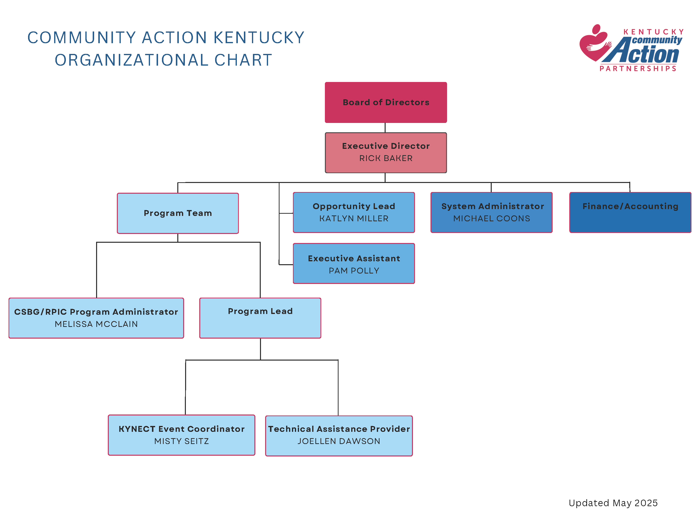

CAK 2022 - RFP for Financial Services
-CONFIDENTIAL- Copyright CAK 2022
P a g e | 8

1 - Chief Financial Officer (Contract)

Overview
The CFO will be accountable for all financial activities. This includes but is not limited to: Monitor Cash Flow, revenues, and expenses
Monitor expenses and ensure that they are in line with the budget
Develop financial plans to assist CAK management and Board of Directors to implement the organizational strategy.
Optimize the use of CAK’s income streams.
Oversee all financial activities (including AR/AP, Payroll, HR, …)
Maintain and update policies and standard operating procedures (SOP) related to Finance and accounting to ensure appropriate internal controls are in place and to provide accurate financials and documentation. Example: CAK’s Finance Policies, SOPs that document AR/AP/ payroll, etc.
Ensure that GAAP, OMB as well as other regulatory and financial reporting standards are adhered to.
Implement processes and provide recommendations to ensure compliance and reduce CAK’s risk.
Communicate financial information to stakeholders such as:
- Finance / Accounting related concerns /updates /suggestions to CAK management
- Regular reporting of CAK’s Financial status and health to CAK management and Board of Directors, including the CAK Finance Committee of the Board of Directors. (CAK’s Board meets bi-monthly)
- Provide CAK staff with financial status of programs and projects
- Suggestions such as process improvement, cost reduction, etc.
The list below contains common elements but may not be an exhaustive list of all activities required.

Compliance and Risk
Monitor and advise on cash flow, revenues, and expenses Ongoing review of CAK financial policies, processes, and practices.
Monitor business operations and ensure that policies and internal controls are followed.
Ensure that CAK is operating programs, completes filing/reporting requirements, and maintains records according to the requirements of the board of directors, applicable funder; Federal, State and/or local regulations (such as OMB compliance).
Take an active role in assessing and mitigating risk to the organization, particularly financial risk. This includes ensuring adequate insurance coverage.

Work with CAK management to identify and mitigate risk
Maintenance of fixed asset schedule; Inventory & Disposal of Assets; Depreciation schedule.
Prepare reports and provide supporting documentation as required by funders (such as FFR reports)
Prepare and file financial reports such as CAK Board Financials, federal, state etc.

Third-Party Audit
CAK is required to undergo an annual third-party audit. The audit is presented to the CAK Board, funders, and filed with the federal clearinghouse. The CAK Finance & Investment Committee selects the auditor through an RFP. The CFO coordinates with the auditor to provide documentation and information as requested, reviews the draft audit, and works to remediate any issues.
The CFO would also track receipts and review audits from subrecipients for findings as required by funders.

Taxes
CAK’s auditor typically develops and submits CAK’s annual federal taxes. The CFO would be responsible for the following:
- Tracking and issuance of W2s, W4s, etc. (typically less than 20 people)
- Collection & storage of W9 forms (typically less than 10)
- Annual preparation & filing of all 1099 forms (typically less than 10)
- Quarterly preparation & submission of sales & use tax forms
- Other tax related items as needed

Charitable Gaming
Manage deposits and payments for CAK’s charitable gaming account. CAK holds a charitable gaming license and a separate gaming account. File reports regarding CAK’s charitable gaming activities (if any). Historically CAK has held 1-2 gaming events per year and the account normally has a handful of transactions per year.
The account must be maintained according to charitable gaming regulations.

Investment
CAK maintains an investment account with a third-party investment firm. The CAK Finance & Investment committee oversees the investments. CAK’s role is to review the monthly statements, record

the realized/unrealized gains, fees, etc., and issue them to the CAK Board and CAK Finance & Investment committee. (the CFO and CAK staff do not choose investments or investment strategies).

Budget – Agencywide and Program/Project specific
CAK maintains an “agency-wide” budget. The Budget is developed by the CFO with input from CAK staff. The Budget is presented to the CAK Finance & Investment Committee (typically in May) ahead of CAK’s annual Board meeting in June. The budget is presented to the CAK Board by the Budget and Finance committee for approval.
  - Develop and maintain agency-wide budget
  - Provide monthly variance budget reports, with breakouts per cost center, program and projects.
  - Identification and calculation of applicable key performance indicators (KPI)
  - Ongoing analysis of budget gaps, identifying areas of achievement & concern
  - Revenue & expense trend observations
  - Assistance in development & oversight of action plans to address budget gaps
  - Plan for cost changes, such as employee benefits, insurance, utilities, etc.
CAK’s Individual Programs and Projects also carry their own budgets. Revenue and expenses must be tracked and reported against the Budget plan for the individual program.
- Provide regular (typically monthly) communication to CAK management and program staff about the financial position of each program/project.
- Provide assistance to CAK Program staff to develop budgets for programs.
- Provide assistance to CAK staff in the development of grant requests, RFP submissions etc. (for example, the CFO will provide assistance in determining estimates of labor and materials costs)

Program Operations Support
CAK operates several programs and grants. CAK’s finance team plays an important role in supporting the Program Team:
  - Support the development and review of contracts and agreements with regard to financial requirements, budget creation and deliverables
  - Works with the Program Team to develop program budgets
  - Monitor revenues and expenses
  - Project program revenue and expenses to avoid shortfalls or under-utilized falls.
  - Oversee the payment schedules and reconciliations for CAK’s programs
  - Assist the program team in meeting financial program deliverables
  - Ongoing advisement regarding best practice in classification & supporting documentation

Monitoring / Reporting & Subject Matter Expert

Subject Matter Expert assisting the program team as well as subrecipients related to financial matters.
Monthly meetings with CAK management to review financial data, projections, fund utilization, budget, cash, etc., more frequent reports may be required towards the end of the fund period.
Provide Financial information to CAK staff Optimize the use of available funds
Projections – fund utilization, budget, cash, etc.
Assistance reviewing business tools used in the execution of operations & strategy
Notify subrecipients of payment details and answer financial questions and provide financial technical support

Monthly Processing and Closeout Activities
Maintain chart of accounts
Monthly reconciliation of each material asset & liability account. This includes bank reconciliation (4 bank and 1 investment account). Two of the bank accounts and the investment accounts have a very low volume of transactions - one has <5 transactions a year and the other has 2-5 transaction a month.
Monthly journal entries related to postage, FSA/HRA clams/payments, investments, depreciation, deferred revenue, prepaid expenses, etc.
Prepared monthly financial statements once expenses/invoices for the prior months have been recorded (typically between the 16th and 30th of the subsequent month)
Maintain and follow internal controls, policies and procedures

“Pass-Through” Financial operations
For those programs where funds are “passed-through” CAK between a funder and CAAs, the CFO will:
  - Provide support to the development of sub-contracts/sub-awards with regard to financial terms
  - Assist with allocations related to dispersing funds to CAAs/subcontractors
  - Monitor and report on program financial status, escalating variances.
  - Monitoring of grant transactions to assist in compliance & facilitate reporting, when applicable

2- Accounting Services AR/AP
General: Cash flow, maximizing revenues and reducing expenditures is critical to CAK’s operations. It also allows CAK to show funders and potential funders that we are a good fiduciary of the funds. AR/AP is an important part of this. The responsibilities include:
  - Ensure that revenues and expense are processed timely, and accurately, with attention to ensuring that they are coded to the correct fund.
  - Ensure that supporting documentation is maintained to satisfy auditors, funders, fund monitors and the public. This requires working closely with the CAK Program Team and staff to understand the rules, requirements, and regulations that programs are required to follow.
  - Work to provide a high degree of service and support to CAK staff, CAA/subcontractors and to funders.

- Accounts Payable
The primary objective for accounts payable and disbursements is to ensure that:
    - Disbursements are properly authorized
    - Invoices are paid in a timely manner
    - Vendor credit terms and operating cash are managed for maximum benefits
    - Expenses are charged to the correct fund and cost center
CAK currently processes AP on a weekly basis and Pass-Through payments as required per agreement. Payments are issues as ACH Direct Deposit and/or “manual check”.
CAK’s largest expenditures are “Pass-Through” payments, where CAK serves as fiscal agent. CAK receives payment from a funder, and then disperses the payment to CAAs/subcontractors. (See the “Pass-Through” funding section.
Weekly AP Payments consist of:
    - Regular payments such as recurring invoices for utilities, insurance, taxes, Microsoft cloud services, etc. Quarterly and Annual payments are made such as for membership dues to other organizations, annual licenses, etc.
    - Reconciliation and payment of credit cards.
    - As-needed payments such as office equipment and supplies, employee travel reimbursement, professional services, etc.

On-demand payments are typically “Pass-Through” payments and occur when triggered by an outside event, such as receipt of payment from a funder. For example, CAK may be required to issue payment to a CAA within 72 hours of receipt of the funds from a funder. Such payments are typically issued to Community Action Agencies as subrecipients/subcontractors, and the timing and frequency is governed by an agreement and dependent upon when the payment has been made to CAK.

Scope of Services:
Process regular AP (currently weekly) and on-demand payments. This includes ensuring supporting documentation and approvals are in place, checking for validity of payments as well as flagging anomalies, payment data entry and issuance, and archiving documentation.
Maintain an orderly filing system
Ensure all reasonable discounts are taken (e.g. for early payment)
Ensure that proper supporting documentation has been submitted for all payments and is maintained Invoices, expense reimbursement with receipts
Vendor & credit card statement reconciliation Communicate to CAK management and staff such as:
AP related concerns / updates
Reimbursement rates (such as mileage rate, per diem, etc.)
Suggestions such as process improvement, recommendations for CAK’s policy, cost reduction, etc.
Maintain and update standard operating procedures (SOP) related to Accounts Payable Example: the checklist scheduled monthly/quarterly/annual payments.
Example: proper documentation of expenses is approved and stored Ensure that policies and internal controls are followed.

- Accounts Receivable
Accounts receivable is critical to the cash flow of an organization and require continuous follow-up and attention. Therefore, it is critical that receivables are processed accurately and timely.
The most common receivables for CAK are:
    - CAK is getting reimbursed for its expenses by the funder
    - CAK receives “pass-through” funding for its subrecipients (e.g., CAAs)
    - CAK receives payment from subrecipients (example: voided expenses.)
    - Collection of membership dues, software fees, rental income, training and event registration fees
    - Payments received from funders such as: Federal and State Government, Corporations, and other non-profit entities.
Payments are largely made to CAK by direct deposit, but some are made by manual check.

Scope Of Services:
Set up accounts receivable to track invoices submitted to customers (funders, CAAs, etc.). Process cash receipts (electronic and manual checks) accurately and timely.

Monitor aging reports and follow up on outstanding receivables. Escalate, as necessary. Communicate to CAK management and staff such as:
    - AR related concerns /updates
    - Suggestions such as process improvement, policy updates etc.
Maintain and update standard operating procedures (SOP) related to Finance/Accounts Receivable Example: the checklist scheduled receivables, following up on missing receivables Example: proper documentation of receipts and processing is approved, and stored
Ensure that policies and internal controls are followed.

Program Invoicing and Billing “Pass-Through” Funding

Program Invoicing and Billing is used for programs where CAK acts as fiscal agent. CAK’s CAA/subcontractors invoice CAK, CAK aggregates the invoices to build a single invoice, then submits the single invoice to the funder.
Program Invoicing and Billing require coordination between AP, AR, as well as the Program Team as reviewing the invoices and supporting documentation is part of ensuring subcontractor's compliance with program operations. CAK submits the invoice to the funder stating that the information has been reviewed and to the best of our knowledge is accurate.
An example of this is the LIHEAP program, where CAK operates the program under contract with the state of Kentucky, and sub-contracts the work to the 23 CAAs. The 23 CAAs invoices CAK for expenses, CAK combines the 23 invoices into one invoice and submits it to the state. The state pays one invoice and CAK then pays the 23 CAAs.

Scope of Services:
Create and maintain invoice templates for subrecipients. (The more efficient and “error proof” the templates are the less burdensome the process is)
Keep up to date with invoice templates and requirements of funders (for example, funders will update their template and reject invoices submitted on out-of-date templates).
Set and/or enforce deadlines in receiving CAA invoices, submitting invoices to funders and processing payments to CAA/sub-contractors. Documentation of such will be required during monitoring.
Communicate with CAA/subcontractors status of invoices, payments, payment advisements, delays etc.
Validate/Reconcile invoices submitted from CAAs with YTD numbers, prior invoices, supporting documentation and/or empowOR system reports.
Example: the year to date should match prior invoices
Example: invoice should reconcile with expenditures in the empowOR reports “Troubleshoot” invoice submissions with CAAs
Example: review invoices and assist CAAs in submitting correct invoices.
Generate and Submit “Pass through” Invoices to funding sources
Example:
CAK is fiscal agent for a program that is subcontracted to 23 CAAs. CAK receives 23 invoices, one from each CAA. The invoices must be validated—meaning that they are reconciled against reports, prior month invoices and the YTD totals. CAK may assist the CAA with correcting invoice

variances as needed. CAK then aggregates the 23 invoices into a single invoice and adds its own expenses. The result is a single invoice that is then submitted to the funding source.

CAK currently processes “Pass-Through” invoices and payments for the following programs: (subject to change)
LIHEAP Invoices- CAK receives 23 invoices, one from each CAA. The invoices must be validated—meaning that they are reconciled against reports, prior month invoices and the YTD totals. CAK may assist the CAA with correcting invoice variances as needed. CAK then aggregates the 23 invoices into a single invoice and adds its own expenses. The result is a single invoice that is then submitted to the funding source. Frequency is bi-weekly. CAK estimates 2 days every, 2 weeks (4 days per month).
KYNECT Invoices: Receive invoices from 6 regions. Combine the invoices to create 1 combined invoice and submit them to the funder. Frequency is monthly. CAK estimates 5-6 days per month.
HEA Invoices- receives and aggregates invoices from multiple CAAs, generates an invoice to each of the 6 funders. Frequency is monthly. CAK estimates approximately 1-2 days per month, with a peak in January and February.

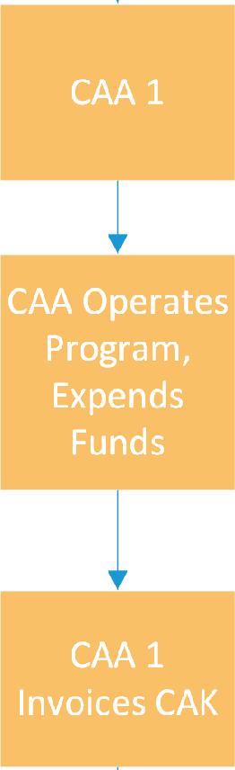
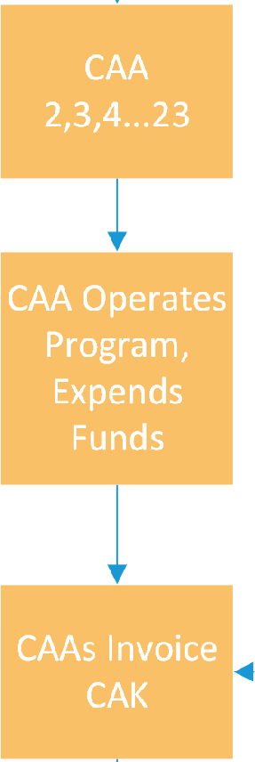
Pass-Through Invoicing Process
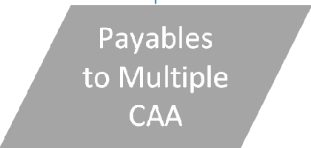
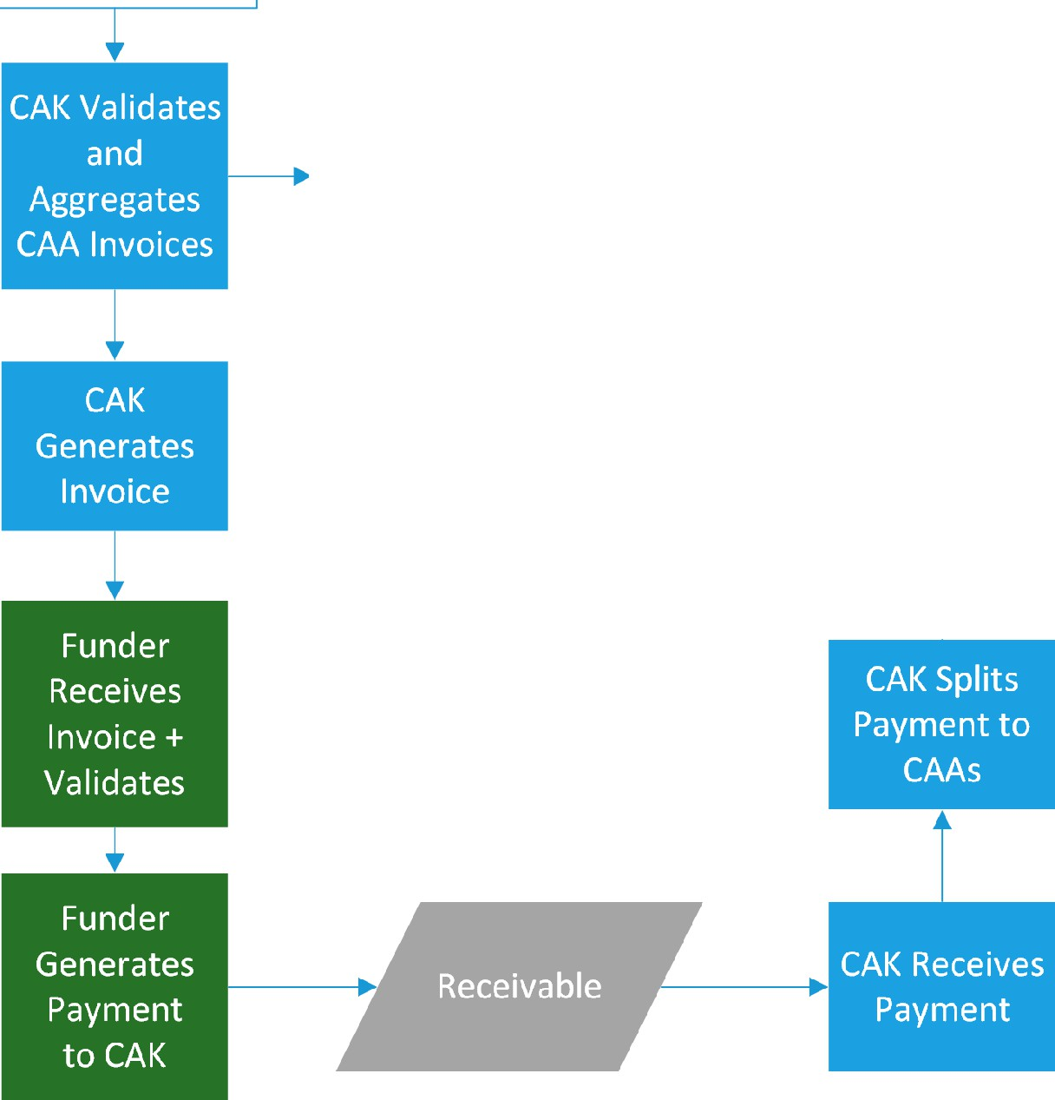
■
I
I I
CAK Issues Payments to
CAAs

Blue are CAK (in scope)

Subcontractor
External CAA or
External Funder (i.e. State)

Payroll

CAK expects to have 5-11 employees paid on a bi-weekly schedule (26 pay periods per year). All employees are paid on an hourly basis to allow charging expenses to the appropriate funds. Some employees are non-exempt and receive overtime while others are exempt and can use the additional hours as comp time.
Critical to getting payroll “right” is the timely and accurate payment to employees, but secondly is the accurate charging of time to contracts and programs (cost centers). Employees record their time on a timesheet in fractions of an hour, and the related expenses are then charged against programs/contracts. Currently CAK has 15-20 cost center codes that employees can charge time to.
Some charges are shared/indirect and will be charged to the appropriate programs using pre-determined formulas across multiple programs. A program may have multiple subcategories, and an hour charged to the program may be spread across its subcategories using a pre-determined formula.
CAK employees accrue annual and medical leave based upon the hours worked and number of service years at CAK.

Scope of Services:
Ensure that all activities related to employee compensation and payroll are carried out timely and accurately. Such as:
- Payroll onboarding/changes/off boarding: Method of payment, withholdings, fringe benefits, required local, state, federal document, .
- Maintain and update timesheet templates and distribute to CAK staff. CAK is open to other methods to track time that meet the program requirements and are easy to use for staff.
- Process Biweekly Payroll for 5-11 employees including:
  - Timesheet processing, Data entry, withholdings, federal, state and local tax withholdings, ACH direct deposit, payroll advisements are provided to employees, employee leave time is accrued and reported
  - Ensure that timesheets and payroll follow internal controls such as proper signoffs by employees, supervisor etc. and documented
  - Ensure that CERS retirement, deferred comp, insurance premiums. etc. are processed properly and in a timely manner.
  - State and federal tax withholdings / 941 tax deposits are collected and processed timely and accurately.
Carry out all Per-Payroll, Monthly, Quarterly and Annual payroll processes such as: Kentucky Retirement (CERS) reporting, IRS 941, flexible spending accounts, unemployment, local withholdings, process W-2s, state and federal withholdings, payment for health, dental, vision, LTD, life insurance, unemployment, etc.
Communicate to CAK management and staff such as: Payroll related concerns, issues, etc.

Changes in HR regulations (example: related to wage and hour) Advise if updates are needed to CAK policy (like HR, Finance) Suggestions such as process improvement, cost reduction
Maintain and update standard operating procedures (SOP) related to Payroll Example: processes and checklists for timesheet submission, reporting, etc.
Ensure that policies and internal controls are followed

Not in Scope:
Determining employee compensation, approving leave, etc.

Sample of Current Timesheet (Exempt) for illustration purposes only.
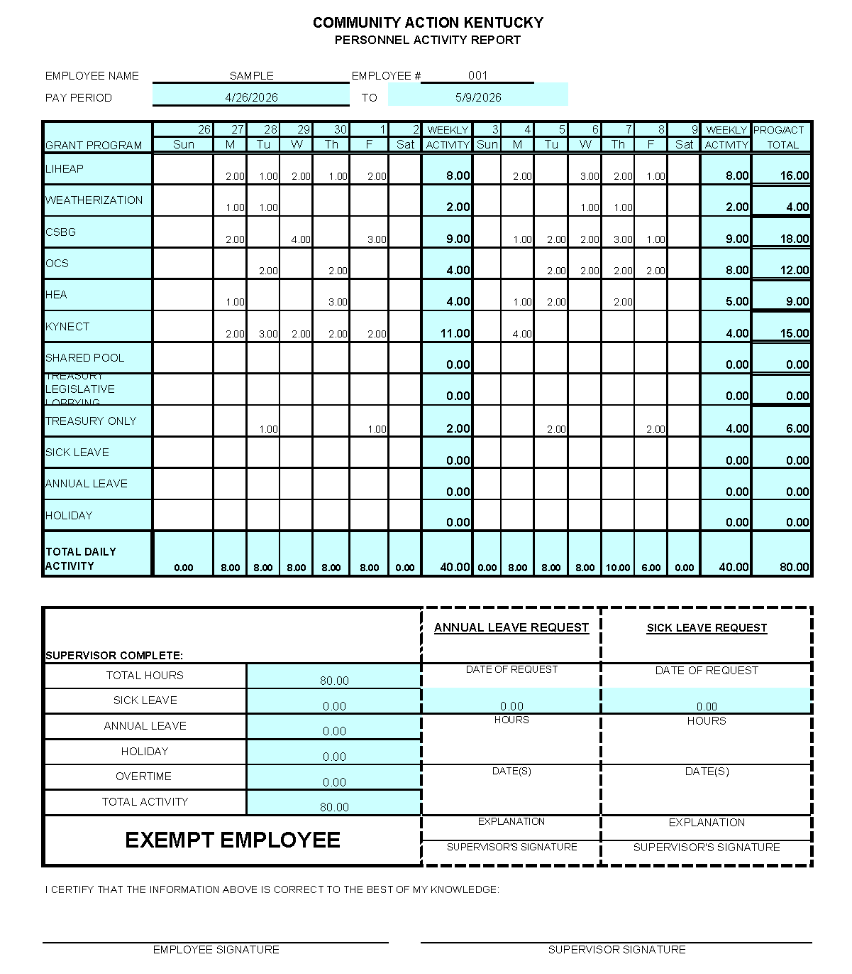

Human Resources

CAK typically has 5-11 employees. CAK has historically had very low turnover, and historically at most one or two employees join or leave the organization per year (if any). The HR functions that CAK is interested in outsourcing are related to the technical and procedural aspects such as notifying third parties of employment status, benefits enrollment, regulatory reporting, etc. We do not plan to outsource the writing of job descriptions, employee evaluations, recruiting etc.
CAK employees are typically eligible to participate in health, dental, vision, long-term disability, life insurance, County Employee Retirement System (CERS), and deferred compensation (401(k)/401(k)Roth/457(b)) which are operated by third parties.

Scope of Services:
Communicate to CAK management and staff such as:
HR/personnel related requirements, concerns, updates and suggestions Changes in HR regulations (example: related to wage and hour)
Advise if updates are needed to CAK Human Resource policy Suggestions such as process improvement, cost reduction
Maintain and update standard operating procedures (SOP) related to HR/personnel Example: the checklist of on-boarding new staff, monthly reporting activities, etc.
Ensure that policies and internal controls are followed Maintain HR personnel files and documentation
Example: maintain records of employee pay rate changes, benefit enrollments, tax forms etc.
Process employee on-boarding and off-boarding Documentation: New hire memo, tax forms etc.
Benefit Enrollment: Health/Life/Vision/Dental/CERS (State Retirement system)/Deferred Compensation/HRA/FSA enrollment etc.
Process off-boarding: benefit disenrollment/COBRA/etc.
Ensure that withholdings are communicated to payroll
Process employee changes (such as to benefits elections, address changes) Process annual open enrollment paperwork
Process required reporting: Title VI report

Reconcile employees against benefits
Example: Regularly verify that all employees are properly enrolled in health insurance, and that separated employees have been dis-enrolled.
Serve as a resource to CAK staff related to HR matters related to benefits enrollment, HRA, FSA, etc.

Not in the scope:
Recruiting new staff, staff development, staff evaluations, job descriptions, disciplinary actions, compensation (except as consideration with program and organizational budget)

Financial Software

CAK currently uses a financial software system called Sage Intact ( https://www.sage.com/en-us/ ) The Sage system runs as a hosted (cloud-based) solution.

CERTIFICATIONS Attachment A
On behalf of the Offeror:
- The individual signing certifies that he/she is authorized to contract on behalf of the Offeror.
- The individual signing certifies that the Offeror is not involved in any agreement to pay money or other consideration for the execution of this agreement, for the purpose of restricting competition.
- The individual signing certifies that the prices in this proposal have been arrived independently, without consultation, communication, or agreement, for the purpose of restricting competition.
- The individual signing certifies that the prices quoted in this proposal have not been knowingly disclosed by the Offeror prior to an award to any other Offeror or potential Offeror.
- The individual signing certifies that there has been no attempt by the Offeror to discourage any potential Offeror from submitting a proposal.
- The individual signing certifies that he/she has read and understands all of the information in this Request for Proposal, and has had an opportunity to submit questions
- The individual signing certifies that the Offeror, and any individuals to be assigned to the project does not have a record of substandard work and has not been debarred or suspended from doing work with any federal, state, or local government. (If the Offeror or any individual to be assigned to the project has been found in violation of any state or AICPA professional standards, this information must be disclosed.)
- The Offeror agrees that all information concerning this RFP and any information it may have access to or become acquainted with during the bid and proposal process, including, but not limited to, CAK’s financial information, business and processes, methods, member agencies, contracts, accounts and procedures, is “Confidential Information.” Other than the RFP bid submitted to CAK, the Offeror agrees not to publish, reproduce, or otherwise divulge such Confidential Information in whole or in part, in any manner or form, or authorize or permit others to do so, and will take such reasonable measures as are necessary to restrict access to the Confidential Information, while in the Offeror’s possession, to those employees on the Offeror’s staff who must have the information on a "need to know" basis. The Offeror agrees to immediately notify, in writing, CAK’s authorized representative in the event the Offeror determines or has reason to suspect a breach of this requirement. Upon request by CAK, the Offeror shall immediately deliver to CAK, all such Confidential Information in its possession or under its control. Submission of a RFP constitutes acceptance of these terms.

Offeror Company Name Date

Signature of Offeror / Offeror Representative

Printed Name and Title of Individual Signing

Appendix B: Approximate Funding

OCS | $ 400,000.00
Weatherization DOE | $ 30,00.00
Weatherization LIHEAP | $ 30,000.00
LIHEAP | $ 78,000,000.00
CSBG | $ 200,000.00
KYNECT | $ 18,497,000.00
HEA Programs | $ 600,000.00
Interest Income | $ 20,000.00
Dues | $ 280,000.00
Rental | $ 22,800.00
Other | $ 152,000.00
Total | $ 101,835,308.00

